
Media Release
Nov. 20, 2025
Jeff Lea
MAC Strategic Communications
jeff.lea@mspmac.org
314-793-4240 (m)

Flight plans: MSP Airport prepares for boost in Thanksgiving travel
Nov. 30 is expected to be busiest day at MSP over next two weeks

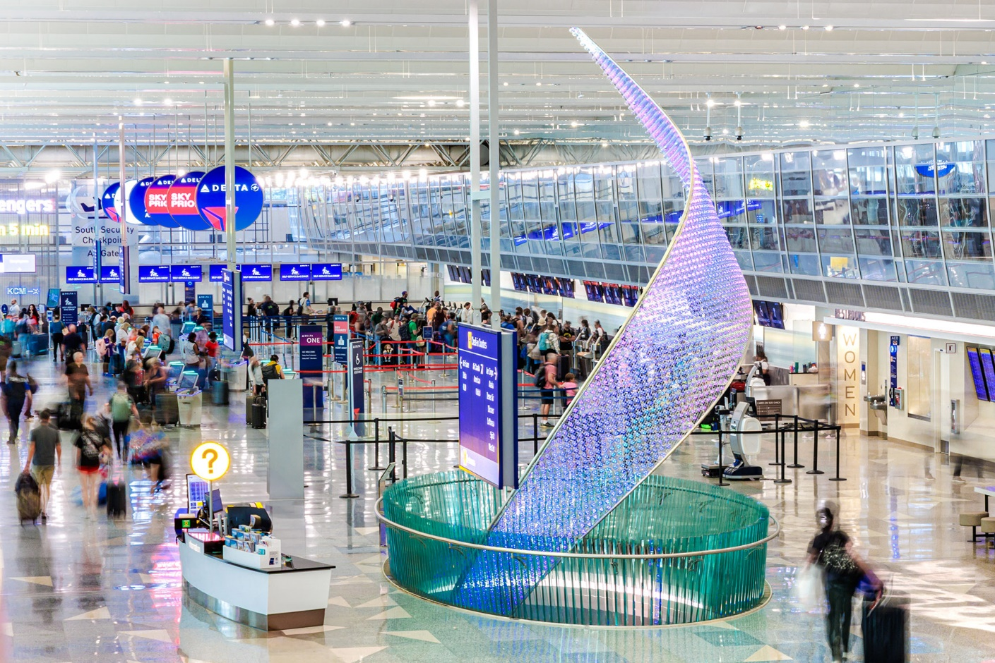
A peak of 49,000 people will clear MSP security checkpoints on the Sunday following Thanksgiving Day. Courtesy of the Metropolitan Airports Commission

MINNEAPOLIS-ST. PAUL, Minn. — Holiday travel gets underway at Minneapolis-St. Paul International Airport (MSP) this week as U.S. travelers head to the skies ahead of Thanksgiving.

Over the course of 12 days between Thursday, Nov. 20, and Monday, Dec. 1, MSP is expecting more than 441,000 people to be screened through security checkpoints, a swing of more than 5% compared to earlier this month.
“We will see passenger activity pick up a week out from Thanksgiving as many get a jump-start on their holiday travels,” said Brian Ryks, CEO of the Metropolitan Airports Commission, which owns and operates MSP. “We’re always excited this time of year to enable memorable holiday and travel experiences for the many who fly from, to and through MSP.”

MSP’s busiest day ahead of the holiday will be Wednesday, Nov. 26, with nearly 47,000 people expected to clear security. The peak travel day will be Sunday, Nov. 30, with more than 49,000 people expected to be screened. The passenger traffic projections spotlight how busy MSP’s ticketing and security checkpoints will be over the next two weeks. This is in addition to connecting passengers and arriving passengers at MSP.
Travelers should prepare for busy roadways and terminal curb areas in relation to the increased driver activity dropping off and picking up passengers. MSP opened a new FLEX Lane at Terminal 1 to provide an additional zone for passenger drop-offs and pick-ups, helping reduce congestion during peak times.

The newly designated FLEX Lane is on the left side of the Terminal 1 Departures Drive roadway across from the primary drop-off curb. This new option offers terminal access through doors 5-8 connected to the Green and Gold parking ramps. A one-level escalator or elevator ride connects to pedestrian sky bridges for a simple “up and over” path to reach the Terminal 1 ticketing lobby. Alternatively, arriving passengers can return to the FLEX Lane for pick-up via the upper-level sky bridges or from below the roadway on Level T.

Terminal 2 also has an alternative pick-up and drop-off area accessible in the Purple Ramp. The free Terminal 2 Express Lane provides a covered loading zone on the second level, offering quick access to the terminal via a sky bridge. Travelers are encouraged to arrive at the airport at least two hours in advance of a domestic flight or three hours before an international flight.

Here are some other helpful tips for Thanksgiving holiday travel at MSP:

- MSP passengers can reserve a spot in the security line for free through MSP RESERVE. Reservation times vary per terminal, and availability is limited.

- Travelers can prebook parking online to guarantee a spot and capture the lowest daily rates. Bookings must be made at least 12 hours prior to scheduled arrival time.

- Travelers in Terminal 1 should check the checkpoint wait-time boards when they enter the ticketing lobby. Passengers can access all gates from either checkpoint, but the North Checkpoint often has shorter wait times.

- In addition to the new FLEX Lane option, drivers can use either level of the terminal drive loop to pick up or drop off passengers.

- To further reduce traffic congestion at curbside pick-up areas, drivers picking up passengers are encouraged to wait in advance at MSP’s free cell phone lots on Post Road. Drivers should stay parked until their arriving party contacts them to pick them up at either terminal.

- Get the latest TSA security screening information and tips including identification requirements and regulated items for carry-on and checked baggage.

About The Metropolitan Airports Commission (MAC)
The Metropolitan Airports Commission (MAC) owns and operates one of the nation’s largest airport systems, including Minneapolis-St Paul International Airport (MSP) and six general aviation airports. MAC’s airports connect the region to the world and showcase Minnesota’s extraordinary culture to millions of passengers from around the globe who arrive or depart through MAC airports each year. Though a public corporation of the state of Minnesota, the organization is not funded by income or property taxes. Instead, the MAC’s operations are funded by rents and fees generated by users of its airports. For more information, visit www.metroairports.org.

